**Dist 30 Meeting Minutes (Area 75)**

**Sep 15, 2023**

**Please note, the District meetings now meet at Wesley Ave Alano Club**

**Attendees:** Joel B, Lori B, Sally T, Jim F, Jim M, David M, Gary L, Mark C, Peter R, Scott W, Judy P

Joel B opened the meeting with the Serenity Prayer

9th tradition read by Scott

9th concept read by Scott

**Treasurer’s Report**

Pete R

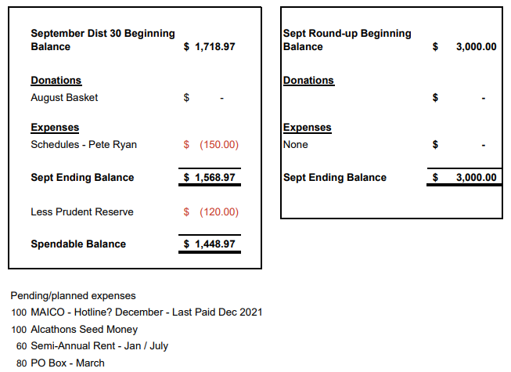

**DCM Report** - Heather Z will send out pre-conference assembly minutes when she receives them.

**GSR Reports**

**Early Risers** - Gary reported they’re doing well and meet at 7:30am every day. Usually discussion from the Daily Reflections. It’s a good group and the doors are always open by 7am. Participation has been good and some newcomes showed up too.

**Keys to the Kingdom** - Jim reported the that meeting is well represented and they have a few newcomers showing up.

**Unity Group** - Scott reported as far as he knows everything is going fine. Attendance has been good.

**Steps to Success** - Jim reported around 12-16 in attendance with regulars and a few newer people attending.

**Milton Tue, Thur and Fri all 7pm** - Sal reported they’re doing good. Tues and Thurs very well attended and Fri night a smaller group of 4-5 people. Next game night is Oct 13th (Friday the 13th) so show up and bring a dish to pass. Wear your costumes too if you want!

**No Name Group -** Gary reported that the Mon big book study/discussion attendance has been growing. The Fri night meeting could use some support and it’s been doing pretty good. The former Wed night meeting no longer meets and a NA meeting meets instead.

**Men in Recovery** - David reported around 25-35 in attendance. Had some newcomes showing up. Meeting has moved back inside.

**Edgerton Group** - Jim reported the Mon meeting is well supported with a good core group and occasionally a new person showing up. The Thurs noon meeting has around 10 attending.

**Blackhawk Good Fellowship** - Scott reported supplies and attendance has been good. Scott is looking for more speakers on Friday nights.

**The Gifts Group** - Jim reported George has been filling in for Phil as he’s resting up at home.

**Beginner’s Group** - No report

**New Voices** - No report

**We are who we are** - Judy reported the Women’s group on Thurs is well attended around 15 showing up and they go out to eat after the meeting! Fellowship Yay!

**As Bill Sees It** - No report

**Mid Morning Group** - No report

**KISS** - Pete reported the meeting is really well attended and they have a rotating chair person (asking for a volunteer at the end of each meeting).

**TNT** - No report

**WOW** - No report

**HOW** - No report

**Committee Reports**

**Archives** - Randy no report

**Women’s Corrections** - Lori reported it’s going well and is continuing efforts to get more volunteers cleared. The 2 groups have about 15 in total. They meet on Wed at 6:30pm and the meetings last until 8 or 8:30pm. The NA groups only come in twice a month so the inmates really appreciate having weekly AA meetings.

**Men’s Corrections** - Jim reported that the Wed 6:30pm men’s group meetings are 20-25 each. The inmates look forward to the meetings and they’re well behaved and generally interested in recovery with good emotional discussions. The 2 meetings last 2-2.5 hrs. Both men’s and women’s corrections have sufficient literature.

**PI/CPC** - Russ no report

**MAICO** - Heather no report

**Treatment** - Phil no report

**Literature/Grapevine** - October Grapevine magazine titled Mid Sobriety Challenges. You can submit a story or artwork to the Grapevine on aagrapevine.org. Order and view AA literature, pamphlets and guidelines directly from AA at aa.org/resources/literature. You can download and try the Grapevine and LaVina apps for free from the Apple App Store and the Google Play Store.

**Old Business** -

**Spring District Roundup -** David reported he stopped by MAICO and their calendar is open to attend our roundup and bring all the goodies (AA books and merch). The Salvation Army would love to have us and their new officers are anxious to hold more events and be more active. They also offered meeting spaces too. The date will be announced soon. David will get a flier created so the roundup committee, which you’re all encouraged to join/get involved, can hold a meeting to pick the date.

**Website -** Voting for a website name occurred and rockcoaa.net was decided. Scott hasn’t been able to get a hold of the old district website manager down in district 8 to try and get rockcoaa.org. Scott will incorporate district meeting attendees in the quality control process before the new website is officially published.

**Meeting Schedules -** if there’s no other meeting changes, we’ll get the new district AA website listed, the 12x12 Drop In Center dropped their land line. The District meeting address will be updated to Wesley Ave Alano Club.

**More Group Participation -** We have quite a few groups with no representation at the District meeting. We had great attendance when Vernice from Rock County Corrections so special guests should help!

**New Business -**

**Spring District Roundup** - David was in contact with both MAICO and Salvation Army and April 20th is looking like the date (almost official). Facility rental is very reasonable. Michelle at the Salvation Army wants a formal application submitted before the contract is generated. David is looking for many hands to make light work. Next roundup planning meeting is Sunday October 8th @ Noon at the 12x12 Drop In Center. Packers play on Monday so no conflicts.

**Website** - Scott reported that the new website is up for testing and suggestions. Font updates occurred to keep the view consistent between desktop and web browsers. Scott is putting new fliers up on the website. Scott was able to obtain 3 yrs of domaing hosting for only $136 in total. Scott will get Pete the receipt.

**New District Meeting schedules** have been printed and distributed.

**Maico** meeting app isn’t updated with the recent meeting changes listed yet. Mark mentioned there is an email address listed in the app that can be contacted with corrections.

**2023 Alkathon** – Wesley Ave Alano Club will host the 2023 Alkathon. Time slots will be drawn at the November District meeting. Host group has the option of hosting the first and/or last timeslots.

**District elections** for the 2024-2025 term will also be held during the November District meeting.

District will provide food/snacks/refreshments when the Area 75 MAICO Rep comes down and speaks. Look for a flier with the date! Donations welcome!

**Area 75 Conference** is Oct 20-24 at the Chula Vista Waterpark Resort in the Wisconsin Dells

**Next district meeting is Fri Oct 6th at 6:30pm at the Wesley Ave Alano Club.**

