**Dist 30 Meeting Minutes (Area 75)**

**May 5, 2023**

**Attendees:** Heather, Joel, Mark, Jim, Peter, Scott, Don, Phil, Grace

Heather Z opened the meeting with the Serenity Prayer

5th tradition read by Jim

5th concept read by Scott

**Treasurer’s Report**

Pete R

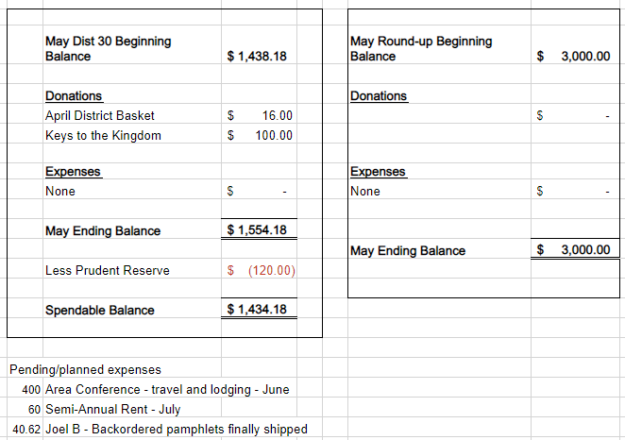

**DCM Report** - Heather Z

Has minutes from the Area 75 spring service assembly and will be emailed out.

**GSR Reports**

**Early Risers** - Jim mentioned good turnout.

**Keys to the Kingdom** - Jim reported they’re doing well and they have a steering committee meeting on the 24th at 11:15am (after the 10am meeting).

**Unity Group** - Is still meeting at Railroad St. Phil mentioned attendance is up and meeting is going good.

**Steps to Success** - Jim reported attendance is up to 16-18.

**Milton Tue, Thur and Fri all 7pm** - Jim mentioned that on Thurs there’s quite a few people there. On June 9th they’re having a game night after 7pm meeting, so from 8-10pm. The last one went great!

**No Name Group -** no name, no report

**Men in Recovery** - David reported it’s going well. Newcomers showing up. They’re discussing possibly having their summer picnic at a new location this year, so stay tuned.

**Edgerton Group** - Grace reported they’re doing good, 6-8 in attendance.

**Blackhawk Good Fellowship** - Scott reported that everything is going well. Meetings are well attended. Set for May speakers.

**The Gifts Group** - Phil reported they’re doing really good now and attendance up over the past couple of weeks. Lots of good snacks and coffee and the meetings are open for both men and women.

**Beginner’s Group** - no report

**New Voices** - Don reported they’re looking for new volunteers to speak and the meetings are well attended. Set for speakers for May.

**We are who we are** - no report

**As Bill Sees It** - no report

**Mid Morning Group** - no report

**KISS** - Peter reported it’s well attended with 20-30 showing up. They have a private facebook page to coordinate chairs for the meeting.

**TNT** - no report

**WOW** - no report but meeting is hybrid and well attended

**HOW** - no report

**Committee Reports**

**Archives** - Randy - no report

**Women’s Corrections** - Lori - no report but they’re well attended and going well.

**Men’s Corrections** - Jim reported 10-18 in attendance for both groups (6:30-8:30pm). 6 AA members chairing the meetings. 6 mos min sobriety, get through a background check, fill out the paperwork and you can help chair too!

**PI/CPC** - Russ - no report but everything is going fine.

**MAICO** - Heather - will get the MAICO meeting minutes fwd out.

**Treatment** - Phil - Crossroads meetings going well. 5 people in rotation speaking. Caravilla weekly meeting has a few attendees.

**Literature/Grapevine** - Joel - New grapevine website coming! Pamphlets ordered last May are finally in route, will be brought to the Jun district meeting.

**Old Business** - David did receive all the Roundup archives, financial records, learnings and even some awesome centerpieces.

Heather will reach out to Shiela to talk about district meeting rent and report back on May 5th.

**New Business -** David reported the fall roundup committee is discussing locations and talking with various venues.

Peter mentioned he’s been hearing commercials for AA on Z104 radio station. Russ, the PI/CPC chair will look into the possibility of district getting the word out about AA.

**District is currently looking for a secretary for the remainder of 2023. Otherwise you’re stuck with Joel.**

**Next meeting is Fri Jun 2nd at 6:30pm at the Unity Group Clubhouse on Railroad St.**