**Dist 30 Meeting Minutes (Area 75)**

**June 2, 2023**

**Please note, the District meetings are moving to the Wesley Ave Alano Club effective next month (July)**

**Attendees:** Heather, Joel, Pete, Phil, Jim, Grace, mark, Russ, Lori Scott, Diane, Jim

Heather Z opened the meeting with the Serenity Prayer

6th tradition read by Jim

6th concept read by Mark

**Treasurer’s Report**

Pete R

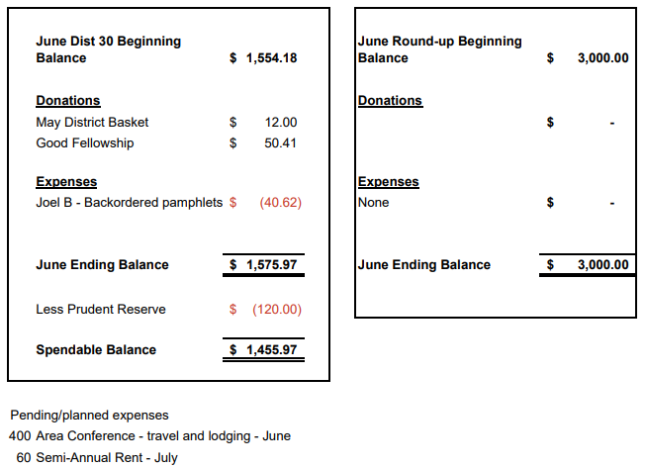

**DCM Report** - Heather Z

The summer service assembly is next Sun June 11th and is hybrid so you can show up at 333 W. Mifflin St in Madison (Senior Center 1st floor) to attend in person.

**GSR Reports**

**Early Risers** - Jim reported they are solvent, well supported with good membership.

**Keys to the Kingdom** - Jim reported they’re well attended, financial stable. They’re doing some landscaping and painting outside at the Wesley clubhouse.

**Unity Group** - Phil reported it’s going good. 15 in attendance usually. The group is still meeting at the Railroad St clubhouse.

**Steps to Success** - Russ reported it’s going good. Averaging 10-20 in attendance.

**Milton Tue, Thur and Fri all 7pm** - Jim reported that Thur is well attended and so is Tues night. Next Friday June 9th is game night! It starts right after the Fri 7pm meeting. It was a really good time last year so suit up, show up and have fun!

**No Name Group -** No report

**Men in Recovery** - Mark reported they’re having their annual picnic July 11th at Palmer Park. Flyers available. Cooking at 5pm, eating at 6 and meeting at 7. Averaging around 24 in attendance and they’re doing A-OK financially. Jim said you can bring your wife and you can bring your girlfriend but don’t bring them both!

**Edgerton Group** - Grace reported the meetings are going well.

**Blackhawk Good Fellowship** - Scott reported the meeting is going well and they’re well attended.

**The Gifts Group** - Phil reported they’re going good. Meetings have a good mix of residence and non-residence.

**Beginner’s Group** - No report

**New Voices** - No report

**We are who we are** - No report

**As Bill Sees It** - No report

**Mid Morning Group** - No report

**KISS** - Diane reported Sunday KISS is well attended with 25-30 showing up. They give out free hardcover big books to newcomers! They have a facebook group too you can join.

**TNT** - No report but meetings are hybrid and well attended.

**WOW** - No report

**HOW** - No report

**Committee Reports**

**Archives** - Randy - No report

**Women’s Corrections** - Lori - Attendance fluctuates from a few to a large group for the meetings out at the jail. More women are needed to step up and help attend these meetings. Different voices connect with different inmates so please help spread our message! Please call Lori B to start the application process so she can help and be the point person between AA and the county jail in regards to clearance. No reason to be concerned about the background check, you might be surprised that you’ll pass. Only requirement is 6mos plus of sobriety. There’s lots of drugs and alcohol in the jails so the incarcerated women don’t generally have anyone in sobriety to talk to other than our AA members who help attend these meetings.

**Men’s Corrections** - Jim reported the men’s meetings are well attended and they always have 2 large groups, so 2 meetings. Most of the inmates really enjoy coming. We currently have (3) pairs of AA members handling the meetings so they only have to attend once a month roughly. The men are well behaved as this is their way to get out of their cells in the evenings.

**PI/CPC** - Russ - nothing new to report

**MAICO** - Heather - will fwd the minutes to the district

**Treatment** - Phil - Thurs at Rock Valley going on from 3-4pm and he has a rotation of 3-4 people who go out there and speak. A few people from Rock Valley attend, 3-4 with 2 regulars. Crossroads is going OK. Phil is looking for more volunteers to speak and tell their story. Again, having different voices and diverse stories reach a greater swath of those in need. Reach out to Phil if you’re interesting in helping out and speaking!

**Literature/Grapevine** - Joel - New Grapevine and La Vina app coming in Sept! Backordered pamphlets arrived. A few recent Grapevine magazines distributed at district. Did you group representative bring any of them back to your meeting? AAGrapevine.org and aa.org/resources/literature.com is how you get to the Grapevine website and AA’s literature site. Grapevine is also on Instagram!

**Old Business** - David reported the fall roundup committee is discussing locations and talking with various venues.

Peter mentioned he’s been hearing commercials for AA on Z104 radio station. Russ, the PI/CPC chair will look into the possibility of district getting the word out about AA.

Heather will reach out to Shiela to talk about district meeting rent and report back on May 5th.

**New Business -**

Roundup - Mark conveyed David’s message that there will be a mid July roundup meeting July 22 at 1pm at the 12x12 to discuss the spring roundup as the new staff at the Salvation Army will be in place.

Russ will get in touch with Area about AA public service announcements. This is a follow-up to last month’s discussion of AA public service announcements airing on a local Madison radio station. The district is investigating doing the same thing down in Rock county on a local radio station.

There was discussion regarding an individual who has been leaving used drug paraphernalia and empty bottles at facilities where meetings are being held. This has resulted in at least one meeting having to leave its meeting space and also the individual in question being barred from several locations. Please be mindful of your surroundings and stay safe.

Motion passed to move the District meeting to Wesley Ave Alano Club and to offer them them $120/yr rent. They’ve offered to host the Dist 30 monthly business meeting. Jim will talk with the board members at Wesley about this financial arrangement.

Mark asked about the district website. There’s been issues with the site being down. District is attempting to obtain the login and password as we have a new webmaster who’s eager to step up and be of service.

The Wed No Name Group at 6:30pm at the 12x12 has folded.

**Next district meeting is Fri Jul 7th at 6:30pm at the Wesley Ave Alano Club.**