**Dist 30 Meeting Minutes (Area 75)**

**July 7, 2023**

**Please note, the District meetings now meet at Wesley Ave Alano Club**

**Attendees:** Pete, Scott, Jim, Jim, Randy, Heather, Joel, Phil

Heather Z opened the meeting with the Serenity Prayer

7th tradition read by Randy

7th concept read by Phil

**Treasurer’s Report**

Pete R

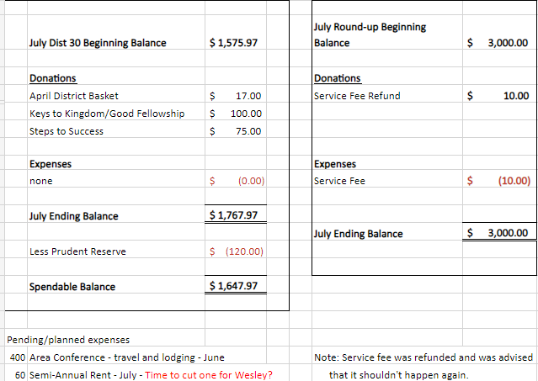

**DCM Report** - Heather Z

Heather attended the summer service assembly on June 11th so no related expenses. She’ll pass along the meeting minutes.

**GSR Reports**

**Early Risers** - Jim reported it’s well attended and financial secure and they read from the Daily Reflections book unless it’s a 1st step meeting.

**Keys to the Kingdom** - Jim reported attendance is 20-40 and they’re financially secure.

**Unity Group** - Phil reported they’re doing good. 10-15 people in attenance. Next Tues at 8pm meeting is the group consious vote to move from the Unity Group Clubhouse to the Wesley Ave Alano Club. If the vote is affirmative, all Unity Group meetings beginning August 1st will be at the Wesley Ave Alano Club. The Sunday 9:30am meeting will need to be moved to an earlier timeslot in the morning as the Sunday Morning Miracle Group meets at 10am on Sundays.

**Steps to Success** - Jim reported the meeting has really grown alot. Some new people showing up and some sticking around for awhile. They will have a summer picnic later on, so keep a look out for that flyer.

**Milton Tue, Thur and Fri all 7pm** - no report

**No Name Group -** Randy reported the Monday Big Book meeting going good with about 15 showing up. Friday meeting with the same attendance. Reminder that the Wednesday meeting shut down.

**Men in Recovery** - Pete reported it’s going good with some nice topics. Next week is the cookout at Palmer Park on Tues July 11th. Cook at 5pm, Eat at 6pm, Meet at 7pm.

**Edgerton Group** - Jim reported around 9 in attendance on average.

**Blackhawk Good Fellowship** - Scott reported everything is going well. Looking for more speakers so reach out to Scott if you’re willing to speak!

**The Gifts Group** - Phil reported Wed at 3:30 and Sat at 1pm meetings are open discussion, all are welcome all genders and there’s not only coffee but snacks too!

**Beginner’s Group** - no report

**New Voices** - Heather reported the meeting is doing good and Scott is speaking this Saturday!

**We are who we are** - no report

**As Bill Sees It** - no report

**Mid Morning Group** - no report

**KISS** - Pete reported attendance is really good and there’s a private facebook page with the topic of the day so people who can’t make the meeting can still share. The meeting chair volunteers are also kept in the facebook page.

**TNT** - no report

**WOW** - no report

**HOW** - no report

**Committee Reports**

**Archives** - Randy reported nothing new to report

**Women’s Corrections** - Looking for more women to help attend and lead these women’s corrections AA meetings. Reach out to Lori B if interested! Only requirement is 6 mos of sobriety.

**Men’s Corrections** - Jim reported there’s 6 men right now leading the meetings so it’s a good rotation. Always looking for more men to help attend and lead these corrections AA meetings.

**PI/CPC** - no report

**MAICO** - Heather will forward out the MAICO minutes. Flyers for the annual MAICO picnic distributed at district.

**Treatment** - Phil reported the speaker meetings are going good.

Crossroads 3rd Thurs of the month at 10:30am and 6pm.

Rock Valley Community Programming last Thurs of the month at 3pm

Still no inroads with Mercy yet.

**Literature/Grapevine** - New Grapevine and LaVina apps coming in Sept. You can become a Grapevine rep right on aagrapevine.org. A few Grapevines were brought to district for your representatives to bring back to your meetings.

**Old Business** - Roundup - Mark conveyed David’s message that there will be a mid July roundup meeting July 22 at 1pm at the 12x12 to discuss the spring roundup as the new staff at the Salvation Army will be in place.

Russ will get in touch with Area about AA public service announcements. This is a follow-up to last month’s discussion of AA public service announcements airing on a local Madison radio station. The district is investigating doing the same thing down in Rock county on a local radio station.

There was discussion regarding an individual who has been leaving used drug paraphernalia and empty bottles at facilities where meetings are being held. This has resulted in at least one meeting having to leave its meeting space and also the individual in question being barred from several locations. Please be mindful of your surroundings and stay safe.

Motion passed to move the District meeting to Wesley Ave Alano Club and to offer them them $120/yr rent. They’ve offered to host the Dist 30 monthly business meeting. Jim will talk with the board members at Wesley about this financial arrangement.

Mark asked about the district website. There’s been issues with the site being down. District is attempting to obtain the login and password as we have a new webmaster who’s eager to step up and be of service.

The Wed No Name Group at 6:30pm at the 12x12 has folded.

**New Business -** Confirmed that the District Roundup will be in the spring at the Salvation Army.

Heather looked into AA public service announcements on the radio and will reach out to WJVL (Janesville FM 107.3).

Wesley Ave Alano Club will accept $60 per 6 months for District Rent.

Continued up-time issues with our District 30 and 8 website. Discussion about creating a new district AA website that abides by the AA Guidelines. Scott looked into website. Motion passed to create a new website and vote passed to budget $200/yr for hosting. Scott will build the website himself. Ideas for the website domain name will be brought to the August District meeting and voted on.

Discussion about lack of meeting and group participation at district meetings outside of the annual Alkathon timeslot drawing. Heather will reach out to Area and see if we can get a special guest/speaker and maybe also provide some pizza at a future district meeting.

District meeting schedule update will be emailed out for corrections. New schedules will be printed after the August district meeting. Make sure you’re reviewing it and providing any changes/updates before August 4th! Please respond to Pete R.

**Next district meeting is Fri Aug 4th at 6:30pm at the Wesley Ave Alano Club.**







