**Dist 30 Meeting Minutes (Area 75)**

**Feb 3, 2023**

**Attendees:** Jim M, Jesse C, Phil D, Don W, Russ G, Randy W, Heather Z, Brandon H, Joel B

Heather Z opened the meeting with the Serenity Prayer

2nd tradition read by Russ

2nd concept read by Phil

**Treasurer’s Report**

Pete R

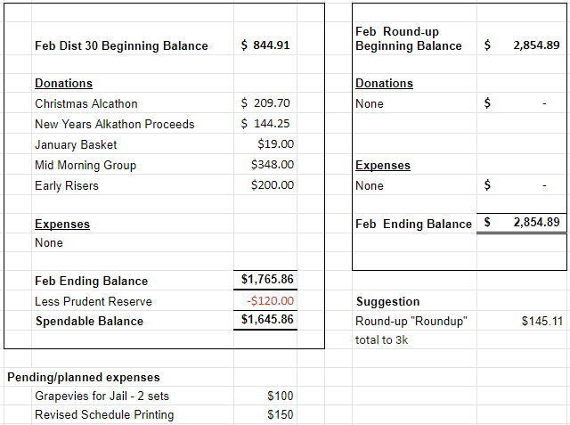

Motion passed to xfer $145.11 from district checking to the round up account to “round up the round up”.

**DCM Report** - Heather Z

Will email out lots of flyers from last weekend’s Area Assembly.

**GSR Reports**

**Early Risers** - no report

**Keys to the Kingdom** - Sal reported 18-23 in attendance. Meeting going good.

**Unity Group** - Phil reported the meetings are going good.

**Steps to Success** - Russ reported Jim will be taking over the GSR position. Jim reported that it’s a smaller group 12-18.

**Milton Tue, Thur and Fri all 7pm** - Lora reported 20-25 showing up on Tue and Thur and Fridays needs support. Phil reported Jim B and the Fri group is planning game nights on Fridays to drum up attendees.

**Home Group at Faith Lutheran** - Meeting closed down on the 6th.

**Men in Recovery** - no report

**Edgerton Group** - no report but a new meeting at Thurs at noon at the church.

**Blackhawk Good Fellowship** - no report

**The Gifts Group** - Phil reported the meetings are open discussion, open to men and women and lots of newcomers showing up. Lots of good snacks and coffee there. Sweets too!

**Beginner’s Group** - Brandon reported it’s going well. 15-25 showing up. Good discussions.

**New Voices** - Don reported it’s well attended. The Walworth County Alano Club is sponsoring the meeting this month. Only need 18 mos of sobriety to speak!

**We are who we are** - Sal reported it’s doing well.

**As Bill Sees It** - no report

**Mid Morning Group** - no report

**KISS** - Diane reported they’re doing good with 20–30 showing up each week. Newcomers get a free big book!

**TNT** - going good and is still a hybrid meeting

**WOW** - no report

**HOW** - no report

**Committee Reports**

**Archives** - Randy has lots of archived speaker tapes anyone can listen to, included those recently and not so recently departed. If any clubhouses have any obituaries or any other archival stuff get ahold of Randy he’d love to add it to the district archives. District Archives will be displayed at the District Round Up.

**Women’s Corrections** - Lori reported they could use more women volunteers to attend the AA meetings. They could use some backup so we don’t have to cancel the women’s weekly AA meeting at the Rock county jail.

**Men’s Corrections** - Brandon reported 2 more men were cleared to attend/lead the men’s weekly AA meeting at the Rock county jail. Currently have 4 men in the rotation and could use more volunteers to help out!

**PI/CPC** - Russ reported Vonnie is still updating the district website. Heather will get it transferred over to Russ. Nothing new to report.

**MAICO** - Heather will get the MAICO minutes sent out.

**Treatment** - Russ reported the programs are going good. Rock Valley Community Programming at Caravila is a small speaker meeting. Crossroads has 2 meetings one a month. Russ has a good lineup of men and women speakers for the next few months. No progress of getting back into Mercy Hospital.

**Literature/Grapevine** - Joel will send out the Jan/Feb Area 75 Grapevine Newsletter.

**Old Business** - Peter suggested we print new schedules with all the changes occurring. A schedule proof is being sent out with these meeting minutes. The plan is to finalize the schedule at the Feb district meeting and have them printed for March. Jim mentioned that District could donate Grapevine subscriptions to the jail and they’ll have them available on their literature cart. Motioned to purchased (2) 2-year Grapevine subscriptions for the Jail (for men and women). Jim Lankford 50th sobriety bday party is at 1pm at the 12x12 on Jan 15th. David asked about the Recovery Roundup fund and if we had a committee still. We do now and David M will chair it. Heather will reach out to Vonnie for past notes/archives/lessons learned.

**New Business -** Jim’s 50th sobriety bday party was awesome! Lots of nice things said and also a good roast too. People from all over attended.

**District is currently looking for a secretary! Get ahold of Heather or show up at the March district meeting if you’re interested. It’ll be Heather’s bday so she wants treats!**

**Next meeting is Fri Mar 3rd at 6:30pm at the Unity Group Clubhouse on Railroad St.**