**Dist 30 Meeting Minutes (Area 75)**

**Aug 4, 2023**

**Please note, the District meetings now meet at Wesley Ave Alano Club**

**Attendees:** Heather, Joel, Jim Diane Jim Phil Scott Mark Scott Gary David Randy

Heather Z opened the meeting with the Serenity Prayer

8th tradition read by Jim

8th concept read by Grace

**Treasurer’s Report**

Pete R

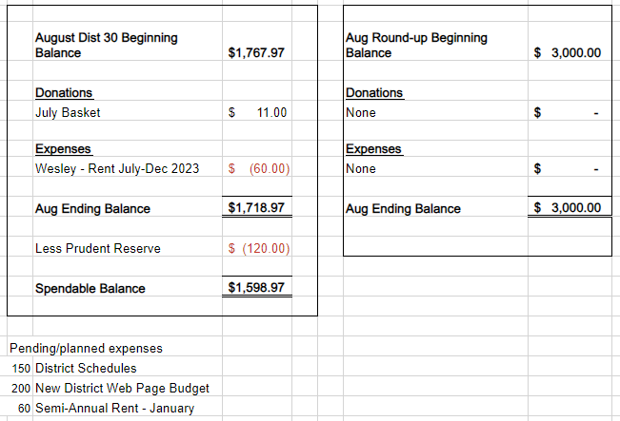

**DCM Report** - Heather Z

Check your emails as Heather will be emailing out her DCM report. Contacted all the AA websites to update the online meeting schedules. Just about everywhere has the updates. Heather talked to a few people and we’ll have some visitors at a future district meeting and food too!

**GSR Reports**

**Early Risers** - Gary reported not alot of changes. Steady attendance. 7:30am every single morning. Discussion is usually from the Daily Reflections but other topics are encouraged. Open meeting.

**Keys to the Kingdom** - Jim reported the meetings are well attended. Really good attendance when there’s banana bread!

**Unity Group** - Phil reported (Unity has no GSR) all meetings moved to Monday was a 7pm at Railroad street and now it’s 5:15 at Wesley The Sunday morning meeting that used to meet 9:30am is now 8:30am at Wesley.

**Steps to Success** - Jim reported a lot of regular attendees. Good attendance and it’s going good.

**Milton Tue, Thur and Fri all 7pm** - Sal reported they’re doing good with solid attendance on Tues and Thurs. Fri night could use support. October 13th is the next Game Night starting at 8pm!!!

**No Name Group -** Randy reported the Monday big book meeting is doing really good and the Friday has decent attendance. Reminder the Wed meeting is shut down now.

**Men in Recovery** - David reported attendance is good and their picnic was a big success. They’re meeting outside while the weather is great.

**Edgerton Group** - Mon 5:45 Grace reported the meeting is doing good. Their name is changing back to the Edgerton Discussion Group on the schedules. Mon Noon Scott reported that the group is growing with 12+ attending. They’re doing good.

**Blackhawk Good Fellowship** - Scott reported the meeting is going well and is going to be reading through paperwork handed down to him from Vonnie. Always looking for more Fri night speakers.

**The Gifts Group** - Phil reported Wed 3:30 and Sat at 1pm discussion meetings have been good. There’s a van from Rock Valley Community Programming showing up with a dozen peopple which is great!

**Beginner’s Group** - no report

**New Voices** - no report

**We are who we are** - Sal reported decent attendance and they’re doing good.

**As Bill Sees It** - no report

**Mid Morning Group** - no report

**KISS** - Diane reported that things are good.

**TNT** - no report

**WOW** - no report

**HOW** - no report

**Committee Reports**

**Archives** - Randy reported nothing new to report

**Women’s Corrections** - Lori reported that one new gal got cleared to help with the women’s meetings and they’re going well!

**Men’s Corrections** - Jim reported that for the men the meetings are going well and the men are well behaved. Enough men for 2 meetings with 10-12 each. Inmates have tablets that contain AA literature. The book cart has Grapevines and other self-help books.

**PI/CPC** - no report

**MAICO** - Heather reported they’re updated their hours. Closed on Mondays but open various hours Tue thru Sun.

**Treatment** - Phil reported they’re down to 1 monthly meeting at Rock Valley. The 2 meetings at Crossroads. Looking for more people to share their stories.

**Literature/Grapevine** - August Grapevine magazine titled AA in the Military. You can become a Grapevine rep right on aagrapevine.org. You can order AA literature directly from AA at aa.org/resources/literature. AA Guidelines can be viewed and printed off for free at AA.org too.

**Old Business** - Confirmed that the District Roundup will be in the spring at the Salvation Army.

Heather looked into AA public service announcements on the radio and will reach out to WJVL (Janesville FM 107.3).

Wesley Ave Alano Club will accept $60 per 6 months for District Rent.

Continued up-time issues with our District 30 and 8 website. Discussion about creating a new district AA website that abides by the AA Guidelines. Scott looked into website. Motion passed to create a new website and vote passed to budget $200/yr for hosting. Scott will build the website himself. Ideas for the website domain name will be brought to the August District meeting and voted on.

Discussion about lack of meeting and group participation at district meetings outside of the annual Alkathon timeslot drawing. Heather will reach out to Area and see if we can get a special guest/speaker and maybe also provide some pizza at a future district meeting.

District meeting schedule update will be emailed out for corrections. New schedules will be printed after the August district meeting. Make sure you’re reviewing it and providing any changes/updates before August 4th! Please respond to Pete R.

**New Business -**

**Spring District Roundup -** David reported he stopped by MAICO and their calendar is open to attend our roundup and bring all the goodies (AA books and merch). The Salvation Army would love to have us and their new officers are anxious to hold more events and be more active. They also offered meeting spaces too. The date will be announced soon. David will get a flier created so the roundup committee, which you’re all encouraged to join/get involved, can hold a meeting to pick the date.

**Webiste -** Voting for a website name occurred and rockcoaa.net was decided. Scott hasn’t been able to get ahold of the old district website manager down in district 8 to try and get rockcoaa.org. Scott will incorporate district meeting attendees in the quality control process before the new website is officially published.

**Meeting Schedules -** if there’s no other meeting changes, we’ll get the new district AA website listed, the 12x12 Drop In Center dropped their land line. The District meeting address will be updated to Wesley Ave Alano Club.

**More Group Participation -** We have quite a few groups with no representation at the District meeting. We had great attendance when Vernice from Rock County Corrections so special guests should help!

**Next district meeting is Fri Sep 8th at 6:30pm at the Wesley Ave Alano Club.**



