**Dist 30 Meeting Minutes (Area 75)**

**Apr 14, 2023**

**Attendees:** Heather, Joel, Pete, Phil, David, Mark, Jim, Jim, Scott, Grace, Don

Heather Z opened the meeting with the Serenity Prayer

4th tradition read by Mark

4th concept read by Jim

**Treasurer’s Report**

Pete R

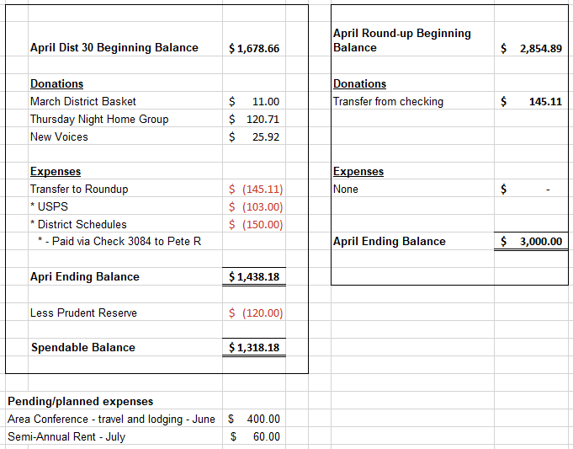

**DCM Report** - Heather Z

Sunday at 9am is the Area 75 spring service assembly. You can register to listen/participate. Also lots of flyers printed off.

**GSR Reports**

**Early Risers** - Jim reported it’s well attended and going well.

**Keys to the Kingdom** - Jim reported they’re doing well and construction is complete so tomorrow at 11:15 am is an open house at Wesley. Everyone is welcome to show up for refreshments and a few giveaways!

**Unity Group** - Phil reported the meetings are well attended and no changes.

**Steps to Success** - Jim reported attendance has improved over the last month and a half.

**Milton Tue, Thur and Fri all 7pm** - David reported he was there last night and made coffee. They have lots of coffee and a mountain of coffee cups. 25 in attendance and the meetings are doing well. They’ll be having another game night on June 9th at 8pm after the 7pm meeting. Friday night attendance is up which is great.

**No Name Group -** Mark reported the Monday night big book study is well attended with 12-15 in attendance.

**Men in Recovery** - David reported he’s back in town from work and the meeting is awesome and very well attended.

**Edgerton Group** - Grace reported the group name is the Edgerton Discussion Group and they meet at 5:45pm on Mondays and it’s going well. The Thurs noon meeting is called the Edgerton Noon Meeting.

**Blackhawk Good Fellowship** - Scott stepped up to run the meeting. Supplies are stocked up and attendance has been good.

**The Gifts Group** - Phil reported everything is going well. Open meetings and both men and women are welcome. 10-20 in attendance depending on the day and other city events.

**Beginner’s Group** - Mark reported some newer faces attending and attendance is around a dozen on Sunday nights.

**New Voices** - Don reported the meeting is going well and 25-40 in attendance. Always looking for more speakers to schedule.

**We are who we are** - no report

**As Bill Sees It** - no report

**Mid Morning Group** - no report

**KISS** - Peter reported some good real topics plus gratitude and is very well attended. Newcomers get a free big book!

**TNT** - no report but the meeting is hybrid and well attended

**WOW** - no report but the meeting is hybrid and well attended

**HOW** - no report but low attendance so they need support

**Committee Reports**

**Archives** - Randy - no report

**Women’s Corrections** - Lori no report but always looking for more women willing to help lead the meetings.

**Men’s Corrections** - Brandon no report but Jim reported that they have 6 men rotating to lead the meeting. Well attended. Rock County would like a third men’s weekly meeting but we’re unable to support that currently. Each meeting is a 2-hour commitment.

**PI/CPC** - Russ - no report

**MAICO** - Heather - emailed out MAICO meeting minutes with the March district meeting minutes mailed out today.

Temporary MAICO hours

Mon 11am-Noon and 6-8pm

Tues 11am-6pm

Wed thru Fri 11am-2pm

Sat Noon-2pm

**Treatment** - Phil - Rock Valley Community Programming is a volunteer based program and there’s been 2 people attending. At Crossroads they have 2 meetings on this coming Thursday and both meetings are well attended. Phil is always looking for more AA members willing to speak/share their stories.

**Literature/Grapevine** - Joel - Many of the AA pamphlet packages are out of stock and/or delayed. Jim asked about “newcomer packets” and a good discussion followed.

**Old Business** - Recovery Roundup - David is chairing the committee and the next planning meeting is on Sat Apr 29th at 2:30-4pm at the 12x12 Drop In Center. Lots to do so show up, be of service and get involved! Many hands make light work.

**New Business -** David did receive all the Roundup archives, financial records, learnings and even some awesome centerpieces.

Heather will reach out to Shiela to talk about district meeting rent and report back on May 5th.

**District is currently looking for a secretary for the remainder of 2023.**

**Next meeting is Fri May 5th at 6:30pm at the Unity Group Clubhouse on Railroad St.**