**District 30 GSR Meeting** Minutes

**October 1, 2021**

**Brandon H, Heather Z, Penny, Linds, Russ G, Dylan B, Phill D, Joel B, Steve R**

1. **Open the meeting with the Serenity Prayer**
2. **Reading Long form of 10th Tradition and 10th Concept**
3. **District Officer’s Reports**
   1. Treasurer: State requiring District to recertify as Tax Exempt: Committee needs to be formed to do this

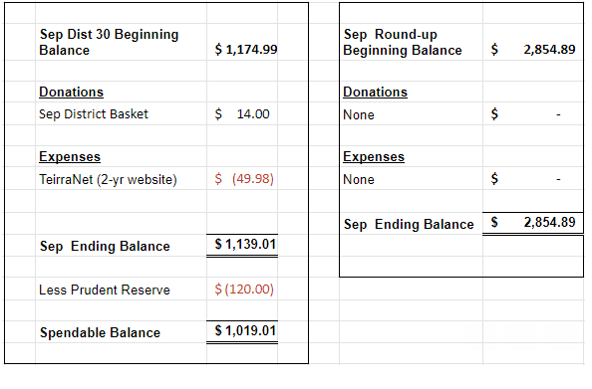

* 1. DCM Report
     1. Area Assembly: Attached proposal passed
     2. Send flyers/schedule updates to [rockcoaa@gmail.com](mailto:rockcoaa@gmail.com)

1. **GSR Reports**
   1. Early Risers (12&12) Daily at 7:30am Brandon H– Doing Well
   2. Sunday Morning Miracle (WAAC) Sundays at 10am - Good topics, good meeting
   3. Unity Group (Railroad) Sun-6pm, Mon-7pm, Tues-7pm, Wed-7pm, *Wed-Noon-Women*, Fri-Noon Phil D- Tues night meeting doing well, Wed doing well – open meeting, Fri is doing well also
   4. Steps to Success (Trinity Episcopal) Wednesdays at 5:30pm Russ G – ave 10-15 people, Having a speaker meeting: Kimberly 5:30pm at Trinity Church
   5. Home Group (Faith Lutheran) Thursdays at 6pm. Russ G– Attendance approx 12-15, next meeting is upstairs due to floor being resurfaced, Church is requiring masks
   6. Men in Recovery Tuesdays at 7pm Steve R***-*** good attendance 30-35, going well,
   7. Sunday Discussion (Faith Lutheran) Sundays at 7pm. Randy W – approx 5 people, doing good***,*** Church is requiring masks
   8. Good Fellowship (WAAC) Wednesdays at Noon; Saturdays at 8am and 10am Penny – 15-20 people, doing good
   9. No Name Group (12&12) Monday, Wednesday, Friday at 6:30pm Randy W – Mon doing well 15-20, Wed smaller, Fri doing well
   10. Beginners Group (12&12) Sundays at 7pm Brandon H – good attendance, 20 people
   11. New Voices (12&12) Saturdays at 7pm Heather Z - Doing well, 25+ attendance, Chuck S will be speaking tomorrow
   12. As Bill Sees It (12&12) Saturdays at 10am Heather Z– Read from As Bill Sees It,4-12 people, good discussion
   13. Mid-Morning Group (12&12) Monday-Friday 10:30AM Brandon H - Going well
   14. Keys to the Kingdom (WAAC) Monday-Friday 10am Penny – Doing well,
   15. We Are Who We Are (WAAC) Thursdays at Noon Penny – doing well, approx 10 people
   16. Edgerton Group – Mon has new meeting place that’s noted on schedule
   17. KISS/Keep It Simple Sunday (12&12) Sundays at 9:30am Brandon H – doing well
   18. **Milton 7pm meetings** Everything Recovery (**Tuesday**); Young at Heart (**Thursday**); Parkview Group (**Friday**) Steve R– Going well, approx 15 people there
   19. Blackhawk Good Fellowship (St. Peter’s) Fridays at 8pm Steve R – Going good, hard to find speakers sometimes, Steve S speaking tonight
   20. The Gifts Group – Closed for 2 weeks, then reevaluate due to a resident having Covid, need donations for thrift shop
   21. TNT (Crosby Ave Recovery House) **Live and Zoom** Tuesdays and Thursdays at 6:30pm Phil D –Doing well - 20-25people
   22. WOW – Women on Wednesday (Crosby Ave Recovery House) **Live and Zoom** Wednesdays at 6:30pm – well attended
   23. Sister’s Doing Steps Linda – needs support
2. **Committee Reports**
   1. Hot Line, Randy W – May give it to MAICO, groups will take it back and discuss it
   2. Archives, Randy W – Nothing New
   3. Women’s Corrections, Lori B – Lori keeping close contact with the jail, no meetings being allowed
   4. Men’s Corrections, Brandon H –
   5. PI/CPC, Open position Russ G – working on schedule in Gazette, checking Area website, District Website
   6. MAICO, Heather Z - Save the date Sat Nov 6 Old-Timers\Young-timers workshop, MAICO Rep Meeting Minutes are attached to same email as Distict Minutes
   7. Treatment/Crossroads, Gary L – on hold with facilities, Mercy Options\Compass\Blackhawk\ ECHO? need updated schedules
   8. Literature and Grapevine, Joel B– Check Grapevine website for more info, they have a new book, lots of events, GrapvineMagazine is now on Instagram. aa.org: have their online store working, updating pamphlets, buy AA Lit within AA structure
   9. Special Needs, Linda – Getting Bus tokens for Recovery house, looking to get money for tokens from District, Micah House is looking for donations
   10. Fall Recovery Round Up, Brandon (October 9, 2021 is on the Salvation Army’s calendar in hopes that Covid will not be an issue this year) – Motion passed to cancel Fall Round-up and look at a Spring or Summer event
3. **Old Business**
4. **New Business**
   1. Dylan B – starting a meeting at Blackhawk tech, looking for donations of books
   2. Bylaws Committee: Dylan, Brandon, Penny, Joel may help as well
   3. Elections: November DCM, alt-DCM, Treasurer, Secretary
5. **Close with Responsibility Statement**

**Upcoming event dates**

* **2021 District 30 GSR Meeting Schedule**

*734 Railroad St - Janesville*

* + November 5
  + December 3
* Pre-Conference Assembly, Location TBD, September 12, 9am
* Area 75 Annual Conference/Conference Assembly, La Crosse, WI, November 12-14
* East Central Regional Conference, August 20-22, Toledo, Ohio
* East Central Regional Forum, November 19-21, Virtual (Independence, OH)