**District 30 GSR Meeting** Minutes

**November 5, 2021**

**Brandon H, Heather Z,Georgee S, Jim C, Steve R, Linda B, Phill D, Joel B, Steve R, Jeff D, Linda D, Cathy**

1. **Open the meeting with the Serenity Prayer**
2. **Reading Long form of 11th Tradition and 11th Concept**
3. **District Officer’s Reports**
   1. Treasurer: State requiring District to recertify as Tax Exempt: Committee needs to be formed to do this

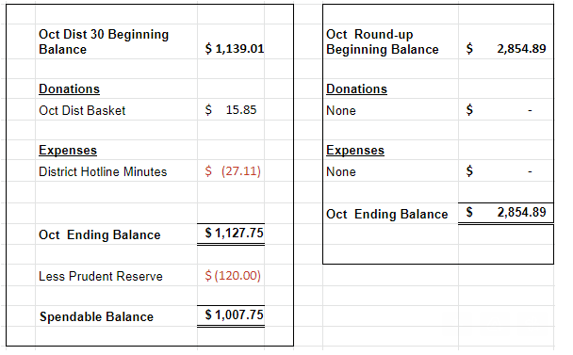

* 1. DCM Report
     1. Elections: DCM – Heather Z, Alt-DCM – Linda B, Treasurer – Steve R, Secretary – Vonnie C
     2. Send flyers/schedule updates to [rockcoaa@gmail.com](mailto:rockcoaa@gmail.com)

1. **GSR Reports**
   1. Early Risers (12&12) Daily at 7:30am Heather Z– Doing Well
   2. Sunday Morning Miracle (WAAC) Sundays at 10am - Good topics, steady meetings
   3. Unity Group (Railroad) Sun-6pm, Mon-7pm, Tues-7pm, Wed-7pm, *Wed-Noon-Women*, Fri-Noon Phil D- Mon,Tues Wed, doing well, Sun – open meeting, Fri is doing well also
   4. Steps to Success (Trinity Episcopal) Wednesdays at 5:30pm Russ G – ave 10-15 people,5:30pm at Trinity Church
   5. Home Group (Faith Lutheran) Thursdays at 6pm. Jeff– Attendance approx 10-15, doing well, Church is requiring masks
   6. Men in Recovery Tuesdays at 7pm Steve R***-*** good attendance 30+, going solid
   7. Sunday Discussion (Faith Lutheran) Sundays at 7pm. Steve R – approx 5 people, doing good***,*** Church is requiring masks
   8. Good Fellowship (WAAC) Wednesdays at Noon; Saturdays at 8am and 10am Penny – 15-30 people, doing good, combining with Keys to the Kindom
   9. No Name Group (12&12) Monday, Wednesday, Friday at 6:30pm Brandon H – Mon doing well 15-20, Wed smaller, Fri doing well
   10. Beginners Group (12&12) Sundays at 7pm Brandon H – good attendance, 20 people ave
   11. New Voices (12&12) Saturdays at 7pm Heather Z - Doing well, speakers lined up for the month, Dylan B speaking Sat
   12. As Bill Sees It (12&12) Saturdays at 10am Heather Z– Read from As Bill Sees It, been smaller but good readings and discussion
   13. Mid-Morning Group (12&12) Monday-Friday 10:30AM Brandon H - Going well
   14. Keys to the Kingdom (WAAC) Monday-Friday 10am Penny – Doing well, combining with Good Fellowship, getting some new people
   15. We Are Who We Are (WAAC) Thursdays at Noon Linda – doing well, getting some new women
   16. Edgerton Group – NR
   17. KISS/Keep It Simple Sunday (12&12) Sundays at 9:30am Diane H– doing well
   18. **Milton 7pm meetings** Everything Recovery (**Tuesday**); Young at Heart (**Thursday**); Parkview Group (**Friday**) Phil D– Going well, approx 15 people there, Fri smaller
   19. Blackhawk Good Fellowship (St. Peter’s) Fridays at 8pm Steve R – Going good, large meetings, Maria from Wesley tonight
   20. The Gifts Group – Opened up again, Sat at 1, Wed at 3:30, 1st Sat is a speaker meeting starting in Dec
   21. TNT (Crosby Ave Recovery House) **Live and Zoom** Tuesdays and Thursdays at 6:30pm Phil D –Doing well - 20-25people
   22. WOW – Women on Wednesday (Crosby Ave Recovery House) **Live and Zoom** Wednesdays at 6:30pm – well attended
   23. Sister’s Doing Steps Linda – 4-8 in attendance
2. **Committee Reports**
   1. Hot Line, Randy W – Motion passed to give hotline to MAICO, with $100 donation\year, collected some new numbers for phone lists, groups to get updated phone lists to give to MAICO
   2. Archives, Randy W – Nothing New
   3. Women’s Corrections, Lori B – Lori keeping close contact with the jail, no meetings being allowed
   4. Men’s Corrections, Brandon H –
   5. PI/CPC, Open position Russ G – working on schedule in Gazette, checking Area website, District Website
   6. MAICO, Heather Z - Save the date Sat Nov 6 Old-Timers\Young-timers workshop, Heather will forward me Minutes from last MAICO meeting
   7. Treatment/Crossroads, Gary L – on hold with facilities, Mercy Options\Compass\Blackhawk\ ECHO? need updated schedules
   8. Literature and Grapevine, Joel B– Grapevine has free shipping for the rest of the year, the have a podcast, a backlog of lit orders fro GSO, so please be patient when ordering
   9. Special Needs/Accessability, Linda – Getting Bus tokens for Recovery house, a report on which committee bus tokens fall under
   10. Fall Recovery Round Up, Brandon (October 9, 2021 is on the Salvation Army’s calendar in hopes that Covid will not be an issue this year) – Motion passed to cancel Fall Round-up and look at a Spring or Summer event

**6. Old Business**

a. Bylaws Committee: Dylan, Brandon, Penny, Joel may help as well – Rough draft completed

**7. New Business**

a. Linda B each out to Wesley to see if they will host 12x12

b. Questions about the change in the AA Preamble were brought up. Email chain of history will be sent to Distirict Email List.

**8. Close with Responsibility Statement**

**Upcoming event dates**

* **2021 District 30 GSR Meeting Schedule**

*734 Railroad St - Janesville*

* + December 3
* Area 75 Annual Conference/Conference Assembly, La Crosse, WI, November 12-14
* East Central Regional Conference, August 20-22, Toledo, Ohio
* East Central Regional Forum, November 19-21, Virtual (Independence, OH)