**District 30 GSR Meeting** Minutes

**May 7, 2021**

**Brandon H, Joel B, Heather Z, Phil D, Wendy K, Jim L, Gary L, Joel B, Ken G, Matt**

1. **Open the meeting with the Serenity Prayer**
2. **Reading Long form of 6th Tradition and 6th Concept**
3. **District Officer’s Reports**
   1. Treasurer – Found Tax exempt: Office Max, Walmart, Sam’s Club, WI sales & Use Tax

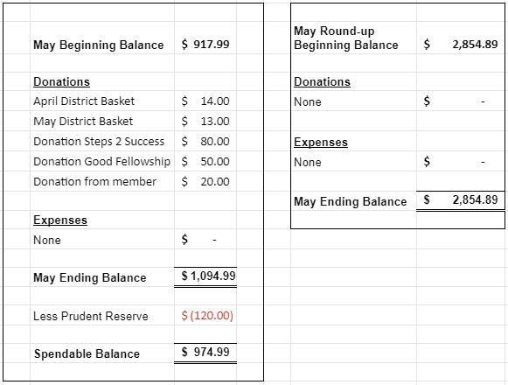

* 1. DCM Report
     1. Michigan State Convention – Oct
     2. Summer Assembly Virtually only – June 27
     3. Dave Goode Dist Webmaster – send flyers to [rockcoaa@gmail.com](mailto:rockcoaa@gmail.com)

1. **GSR Reports**
   1. Early Risers (12&12) Daily at 7:30am Gary L– Good attendance, Read from Daily reflections, good discussions, masks optional
   2. Sunday Morning Miracle (WAAC) Sundays at 10am - NR
   3. Unity Group (Railroad) Sun-6pm, Mon-7pm, Tues-7pm, Wed-7pm, *Wed-Noon-Women*, Fri-Noon Phil D- Tues night meeting going very well, some others are smaller, things going well, masks optional
   4. Steps to Success (Trinity Episcopal) Wednesdays at 5:30pm Russ G – ave 15-20 people, doing well
   5. Home Group (Faith Lutheran) Thursdays at 6pm. Wendy K – attendance picking up, they are wearing masks until July
   6. Men in Recovery Tuesdays at 7pm Mark C***-*** back at Trinity, good attendance 30-35, going well, they are having a picnic July 13 at Sportsman park for their 25th anniversary, flyer forthcoming
   7. Sunday Discussion (Faith Lutheran) Sundays at 7pm. Jim L – 13 people, doing good
   8. Good Fellowship (WAAC) Wednesdays at Noon; Saturdays at 8am and 10am – NR
   9. No Name Group (12&12) Monday, Wednesday, Friday at 6:30pm Randy W – Mon doing well, Wed doing OK, Fri doing well – doing OK
   10. Beginners Group (12&12) Sundays at 7pm Brandon H – good attendance, 20 people
   11. New Voices (12&12) Saturdays at 7pm **Live and Zoom** - Doing well, 30+ attendance
   12. Saturday Morning Serenity (12&12) Saturdays at 10am Brandon H– Read from As Bill Sees It, good discussion
   13. Mid-Morning Group (12&12) Monday-Friday 10:30AM Heather Z - been kind of slow latel
   14. Keys to the Kingdom (WAAC) Monday-Friday 10am Penny – Doing well, attendance growing, masks optional
   15. We Are Who We Are (WAAC) Thursdays at Noon Penny – 12-15 people, good discussion
   16. Edgerton Group – a meeting at noon,More info will be coming
   17. KISS/Keep It Simple Sunday (12&12) Sundays at 9:30am Brandon– Still meeting, doing well
   18. **Milton 7pm meetings** Everything Recovery (**Tuesday**); Young at Heart (**Thursday**); Parkview Group (**Friday**) Phil D – Going well, approx 20 people there
   19. Blackhawk Good Fellowship (St. Peter’s) Fridays at 8pm Heather Z- Good attendance, WICYPAA speaking for June?
   20. The Gifts Group - Wednesdays at 3:30pm and Saturdays at 1pm. Phil D – June 23 meetings are opening to the public, open meeting to men and women
   21. TNT (Crosby Ave Recovery House) **Live and Zoom** Tuesdays and Thursdays at 6:30pm Matt **-** meetings going well15-20 attendance
   22. WOW – Women on Wednesday (Crosby Ave Recovery House) **Live and Zoom** Wednesdays at 6:30pm – meetings going well
   23. Sister’s Doing Steps – First Meeting was May 4, meeting every Tues at 6pm, doing OK now
2. **Committee Reports**
   1. Hot Line, Jim L – no calls, Jim L is looking for a new volunteer, bring back to groups
   2. Archives, Randy W – nothing new, always looking for donations
   3. Women’s Corrections, Lori B -
   4. Men’s Corrections, Brandon H – Brandon to call jail for status
   5. PI/CPC, Open position Russ G – NR
   6. MAICO, Open position - NR
   7. Treatment/Crossroads, Gary L – on hold with various facilities
   8. Literature and Grapevine, Joel B – New Book: Free on the Inside – stories of recovery in prison

a. GSO launching reduced Shipping program, Box 459 are available on aa.org,

b. Grapevine: looking for submissions of stories, cartoons, or captions for the cartoons, Signing up for Grapevine rep is free, New book from AA “ A Visual History of Alcoholics Anonymous – an archival Journey” was to be released at the 2020 Convention.

* 1. Special Needs, Open position - NR
  2. Fall Recovery Round Up, Vonnie (October 9, 2021 is on the Salvation Army’s calendar in hopes that Covid will not be an issue this year)

1. **Old Business**
   * 1. MAICO and Area Website, and District website are updated.
     2. Be sure to let people know about our website! [www.rockcoaa.org](http://www.rockcoaa.org/)
2. **New Business**
   1. Go to other meetings to to promote District participation
   2. Jim L - GSR Wed noon meeting
   3. Print Schedules – smaller runs, change format to fit on 8x11in?

1. Brandon to call Pete to get the format and send out with Minutes

2. Disperse $100 to MAICO, Area, and GSO

3.

1. **Close with Responsibility Statement**

**Upcoming event dates**

* **2021 District 30 GSR Meeting Schedule**

*734 Railroad St - Janesville*

*Zoom ID: 858 4582 4553 Passcode: District30*

* + July 9 *(1st Friday is July 2nd – holiday weekend)*
  + August 6
  + September 3
  + October 1
  + November 5
  + December 3
  + Hybrid meeting, meaning in person and via Zoom
* Summer Assembly, Location TBD, June 27th, 9am/
* Pre-Conference Assembly, Location TBD, September 12, 9am
* Area 75 Annual Conference/Conference Assembly, La Crosse, WI, November 12-14
* East Central Regional Conference, August 20-22, Toledo, Ohio
* East Central Regional Forum, November 19-21, Virtual (Independence, OH)