**District 30 GSR Meeting** Minutes

**July 9, 2021**

**Brandon H, Heather Z, Phil D, Wendy K, Jim L, Gary L, Russ G., Cathy G, Andrea**

1. **Open the meeting with the Serenity Prayer**
2. **Reading Long form of 6th Tradition and 6th Concept**
3. **District Officer’s Reports**
   1. Treasurer – Found Tax exempt: Office Max, Walmart, Sam’s Club, WI sales & Use Tax

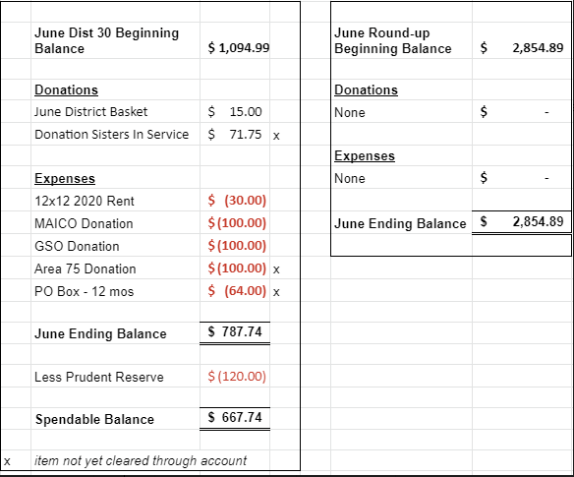

* 1. DCM Report
     1. Summer Assembly Virtually only – June 27
        1. Pre-Conference – Sep 12
        2. Area 75Conference Nov 12-14
     2. Dave Goode Dist Webmaster – send flyers to [rockcoaa@gmail.com](mailto:rockcoaa@gmail.com)

1. **GSR Reports**
   1. Early Risers (12&12) Daily at 7:30am Gary L– Good attendance 25-30ppl, Read from Daily reflections, good discussions
   2. Sunday Morning Miracle (WAAC) Sundays at 10am - NR
   3. Unity Group (Railroad) Sun-6pm, Mon-7pm, Tues-7pm, Wed-7pm, *Wed-Noon-Women*, Fri-Noon Phil D- Tues night meeting going very well, Wed doing well, things going well
   4. Steps to Success (Trinity Episcopal) Wednesdays at 5:30pm Russ G – ave 10-15 people, Going well, Cookout Aug 28 5pm At Traxler
   5. Home Group (Faith Lutheran) Thursdays at 6pm. Wendy K – attendance picking up, not doing speaker meetings except for the Chili Cook-off
   6. Men in Recovery Tuesdays at 7pm Mark C***-*** good attendance 30-35, going well, they are having a picnic July 13 at Sportsman park for their 25th anniversary, food at 6pm, meeting at 7p
   7. Sunday Discussion (Faith Lutheran) Sundays at 7pm. Randy W – 6-10 people, doing good
   8. Good Fellowship (WAAC) Wednesdays at Noon; Saturdays at 8am and 10am – NR
   9. No Name Group (12&12) Monday, Wednesday, Friday at 6:30pm Randy W – Mon doing well, Wed smaller, Fri doing well
   10. Beginners Group (12&12) Sundays at 7pm Brandon H – good attendance, 20-30 people
   11. New Voices (12&12) Saturdays at 7pm **Live and Zoom** - Doing well, 25+ attendance, Mark C speaking this Sat
   12. Saturday Morning Serenity (12&12) Saturdays at 10am Heather Z– Read from As Bill Sees It, smaller group, good discussion
   13. Mid-Morning Group (12&12) Monday-Friday 10:30AM Brandon H - Going well
   14. Keys to the Kingdom (WAAC) Monday-Friday 10am Penny – Back to pre-covid atendance
   15. We Are Who We Are (WAAC) Thursdays at Noon Penny – 12-15 people, good discussion
   16. Edgerton Group – a meeting at noon,More info will be coming
   17. KISS/Keep It Simple Sunday (12&12) Sundays at 9:30am Wendy K– Attendance doing good
   18. **Milton 7pm meetings** Everything Recovery (**Tuesday**); Young at Heart (**Thursday**); Parkview Group (**Friday**) Phil D – Going well, approx 15 people there
   19. Blackhawk Good Fellowship (St. Peter’s) Fridays at 8pm - NR
   20. The Gifts Group - Wednesdays at 3:30pm and Saturdays at 1pm. Phil D –meetings are opening to the public, open meeting to men and women
   21. TNT (Crosby Ave Recovery House) **Live and Zoom** Tuesdays and Thursdays at 6:30pm **-** NR
   22. WOW – Women on Wednesday (Crosby Ave Recovery House) **Live and Zoom** Wednesdays at 6:30pm – NR
   23. Sister’s Doing Steps Cathy G – 5-10ppl, attendance picking up
2. **Committee Reports**
   1. Hot Line, – NR
   2. Archives, Randy W – nothing new, always looking for donations
   3. Women’s Corrections, Lori B -
   4. Men’s Corrections, Brandon H – inmates being taken into jail, still not allowing meetings, will continue to check
   5. PI/CPC, Open position Russ G – nothing new
   6. MAICO, Open position - NR
   7. Treatment/Crossroads, Gary L – on hold with facilities
   8. Literature and Grapevine, Joel B– NR
   9. Special Needs, Open position - NR
   10. Fall Recovery Round Up, Brandon (October 9, 2021 is on the Salvation Army’s calendar in hopes that Covid will not be an issue this year) – Call Salvation Army
3. **Old Business**
4. **New Business**
   1. Print Schedules – proof sent to District email list, will compile changes on 7-16-21
   2. Round-up – Brandon to call Salvation Army to check on if they are having events, will send an email to District email list
   3. Zoom will not available for District 30 meetings anymore
5. **Close with Responsibility Statement**

**Upcoming event dates**

* **2021 District 30 GSR Meeting Schedule**

*734 Railroad St - Janesville*

*Zoom ID: 858 4582 4553 Passcode: District30*

* + August 6
  + September 3
  + October 1
  + November 5
  + December 3
* Pre-Conference Assembly, Location TBD, September 12, 9am
* Area 75 Annual Conference/Conference Assembly, La Crosse, WI, November 12-14
* East Central Regional Conference, August 20-22, Toledo, Ohio
* East Central Regional Forum, November 19-21, Virtual (Independence, OH)