**District 30 GSR Meeting** Minutes

**December 3, 2021**

**Brandon H, Mark C, Jim L, Russ G, Joe S, Darius (Reverend Jim), Gary L, Heather Z, Laura H, Phil D, Steve R, Jeff L, Sally T, Mike S,**

1. **Open the meeting with the Serenity Prayer**
2. **Reading Long form of 12th Tradition and 12th Concept**
3. **District Officer’s Reports**
   1. Treasurer: State requiring District to recertify as Tax Exempt: Committee needs to be formed to do this

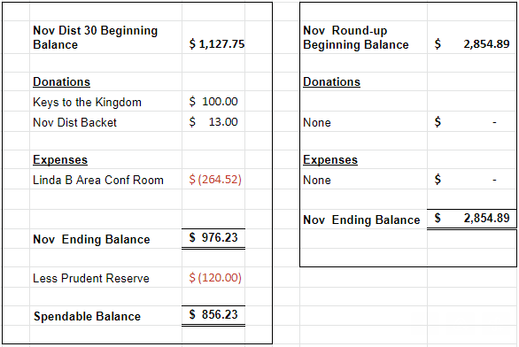

* 1. DCM Report
     1. Alcathon Drawing: See Attached List
     2. Send flyers/schedule updates to [rockcoaa@gmail.com](mailto:rockcoaa@gmail.com)

1. **GSR Reports**
   1. Early Risers (12&12) Daily at 7:30am Gary L– Meet every day, 20-25, more on weekends
   2. Sunday Morning Miracle (WAAC) Sundays at 10am - NR
   3. Unity Group (Railroad) Sun-6pm, Mon-7pm, Tues-7pm, Wed-7pm, *Wed-Noon-Women*, Fri-Noon Phil D- Mon,Tues Wed, 10-20 people, Sun – open meeting, Fri is doing well also
   4. Steps to Success (Trinity Episcopal) Wednesdays at 5:30pm Russ G – ave 10-18 people, Speaker on Jan flyers forthcomming
   5. Home Group (Faith Lutheran) Thursdays at 6pm. Jeff– Attendance approx 6-12, doing well, Church is requiring masks, bring your own coffee
   6. Men in Recovery Tuesdays at 7pm Mark C***-*** good attendance 30-35, Raised $111 for Gratitiude Month, Meeting on Dec 7 & 14 will be at Wesley, going back to Trinity after 12-14
   7. Sunday Discussion (Faith Lutheran) Sundays at 7pm. – Meeting is Closed for now
   8. Good Fellowship (WAAC) Wednesdays at Noon; Saturdays at 8am and 10am – has combined with Keys to the Kindom
   9. No Name Group (12&12) Monday, Wednesday, Friday at 6:30pm Jim L – Mon doing well 15-20, Wed smaller, Fri doing well
   10. Beginners Group (12&12) Sundays at 7pm Brandon H – good attendance, 20 people ave
   11. New Voices (12&12) Saturdays at 7pm Heather Z - Doing well, speakers lined up for the month, Ron W speaking Sat Dec 4
   12. As Bill Sees It (12&12) Saturdays at 10am Heather Z– Read from As Bill Sees It, been smaller but good
   13. Mid-Morning Group (12&12) Monday-Friday 10:30AM Jim L - Going well, getting bigger
   14. Keys to the Kingdom (WAAC) Monday-Friday 10am Penny – Doing well, combined with Good Fellowship, 20-25 people
   15. We Are Who We Are (WAAC) Thursdays at Noon – doing well, getting some new women 12-17, new GSR Sally Tucker
   16. Edgerton Group – Dan S trying to open club in Edgerton
   17. KISS/Keep It Simple Sunday (12&12) Sundays at 9:30am Luara H– approx 20 people
   18. **Milton 7pm meetings** Everything Recovery (**Tuesday**); Young at Heart (**Thursday**); Parkview Group (**Friday**) Laura H– Going well, approx 15 people there, Fri smaller
   19. Blackhawk Good Fellowship (St. Peter’s) Fridays at 8pm Steve R – 30+ attendance, going well
   20. The Gifts Group Phil D – meeting growing, open meetings
   21. TNT (Crosby Ave Recovery House) **Live and Zoom** Tuesdays and Thursdays at 6:30pm Darious –Doing well – 15-25people, hybrid meetings are still
   22. WOW – Women on Wednesday (Crosby Ave Recovery House) **Live and Zoom** Wednesdays at 6:30pm – 6-12, 12x12 format, hybrid meetings
   23. Sister’s Doing Steps – Needs support
2. **Committee Reports**
   1. Hot Line, Joel B – Motion passed to give hotline to MAICO, with $100 donation\year, collected some new numbers for phone lists, groups to get updated phone lists to give to MAICO, will have to Hotline number at next schedule printing
   2. Archives – Nothing New
   3. Women’s Corrections, Lori B – Lori keeping close contact with the jail, no meetings being allowed
   4. Men’s Corrections, Brandon H –
   5. PI/CPC, Open position Russ G – working on schedule in Gazette, checking Area website, District Website, verified schedules are on sites
   6. MAICO, Heather Z - MAICO meeting Dec 16 at 7pm, need 3 new members for Steering Committee, Heather will email last meeting Minutes
   7. Treatment/Crossroads, Gary L – on hold with facilities, Mercy Options\Compass\Blackhawk\ ECHO? need updated schedules
   8. Literature and Grapevine, Joel B– Grapevine has free shipping for the rest of the year, the have a podcast
   9. Special Needs/Accessability, Linda – Getting Bus tokens for Recovery house, a report on which committee bus tokens fall under
   10. Fall Recovery Round Up, Brandon (October 9, 2021 is on the Salvation Army’s calendar in hopes that Covid will not be an issue this year) – Motion passed to cancel Fall Round-up and look at a Spring or Summer event

**6. Old Business**

a. Bylaws Committee: Dylan, Brandon, Penny, Joel may help as well – Rough draft completed

b. Questions about the change in the AA Preamble were brought up. Email of history was sent to District Email List.

**7. New Business**

a. New Schedule Printing – Sunday Discussion Closed, Add We are Who we Are, New Hot line Number, Contact Pete to get schedules printed, $150 approved

**8. Close with Responsibility Statement**

**Upcoming event dates**

* **2022 District 30 GSR Meeting Schedule**

*734 Railroad St - Janesville*

* + January 7, 2022
  + February 4, 2022
  + March 4, 2022
  + April 1, 2022
  + May 6, 2022
  + June 3, 2022
  + July 8, 2022 (1st Friday is July 1, move for 4th of July holiday)
  + August 5, 2022
  + September 9, 2022 (1st Friday is Sep 2, Move for Labor Day holiday)
  + October 7, 2022
  + November 4, 2022
  + December 2, 2022
* **Christmas Alcathon**
  + Held at Wesley Av Alano Club – 1833 Wesley Avenue - Janesville
  + 6pm Dec 24 – 6pm Dec 25
* **New Year’s Acathon**
  + Held at Wesley Av Alano Club – 1833 Wesley Avenue – Janesville
  + 6pm Dec 31 - 6am Jan 1