**District 30 GSR Meeting** Minutes

**August 5, 2021**

**Brandon H, Heather Z, Jim L, Mark C, Pete R , Cathy G, Russ G, Phil D, Joel B, Andrea , Diane H**

1. **Open the meeting with the Serenity Prayer**
2. **Reading Long form of 8th Tradition and 8th Concept**
3. **District Officer’s Reports**
   1. Treasurer – Has Tax exempt info: Office Max, Walmart, Sam’s Club, WI sales & Use Tax

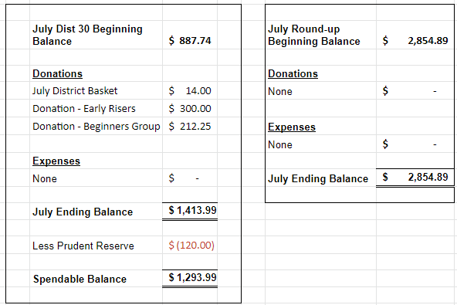

* 1. DCM Report
     1. NR
     2. Send flyers/schedule updates to [rockcoaa@gmail.com](mailto:rockcoaa@gmail.com)

1. **GSR Reports**
   1. Early Risers (12&12) Daily at 7:30am Gary L– Doing Well
   2. Sunday Morning Miracle (WAAC) Sundays at 10am - NR
   3. Unity Group (Railroad) Sun-6pm, Mon-7pm, Tues-7pm, Wed-7pm, *Wed-Noon-Women*, Fri-Noon Phil D- Tues night meeting going very well, Wed doing well, things going well
   4. Steps to Success (Trinity Episcopal) Wednesdays at 5:30pm Russ G – ave 10-15 people, Going well, Cookout Aug 28 5pm at Traxler
   5. Home Group (Faith Lutheran) Thursdays at 6pm. Jim L – Attendance approx, not doing speaker meetings except for the Chili Cook-off, Church is requiring masks
   6. Men in Recovery Tuesdays at 7pm Steve R***-*** good attendance 30-35, going well, picnic was a success
   7. Sunday Discussion (Faith Lutheran) Sundays at 7pm. Randy W – 6-10 people, doing good***,*** Church is requiring masks
   8. Good Fellowship (WAAC) Wednesdays at Noon; Saturdays at 8am and 10am – NR
   9. No Name Group (12&12) Monday, Wednesday, Friday at 6:30pm Brandon – Mon doing well, Wed smaller, Fri doing well
   10. Beginners Group (12&12) Sundays at 7pm Brandon H – good attendance, 20-30 people
   11. New Voices (12&12) Saturdays at 7pm Heather Z - Doing well, 25+ attendance, playing video of AA member that passed away this Sat
   12. As Bill Sees It (12&12) Saturdays at 10am Heather Z– Read from As Bill Sees It, 10-12 people, good discussion
   13. Mid-Morning Group (12&12) Monday-Friday 10:30AM Brandon H - Going well
   14. Keys to the Kingdom (WAAC) Monday-Friday 10am Jim L – Doing well
   15. We Are Who We Are (WAAC) Thursdays at Noon – NR
   16. Edgerton Group – Mon has new meeting place that’s noted on schedule
   17. KISS/Keep It Simple Sunday (12&12) Sundays at 9:30am Dian H– Attendance doing good 15-30
   18. **Milton 7pm meetings** Everything Recovery (**Tuesday**); Young at Heart (**Thursday**); Parkview Group (**Friday**) Phil D – Going well, approx 15 people there
   19. Blackhawk Good Fellowship (St. Peter’s) Fridays at 8pm Steve R – Going good, Flyers for Aug speakers are out
   20. The Gifts Group - Wednesdays at 3:30pm and Saturdays at 1pm. Phil D –meetings are opening to the public, open discussion meeting, open to men and women, golf outting Sep 18 1pm go on Gifts website for details
   21. TNT (Crosby Ave Recovery House) **Live and Zoom** Tuesdays and Thursdays at 6:30pm –Sep 3 music jam, Sep 4 BBQ cook off, food at noon
   22. WOW – Women on Wednesday (Crosby Ave Recovery House) **Live and Zoom** Wednesdays at 6:30pm – well attended, 15-20 ppl
   23. Sister’s Doing Steps Diane H – 10-12ppl, doing well
2. **Committee Reports**
   1. Hot Line, – NR
   2. Archives, Randy W – NR
   3. Women’s Corrections, Lori B – Lori keeping close contact with the jail, no meetings being allowed
   4. Men’s Corrections, Brandon H –
   5. PI/CPC, Open position Russ G – will verify schedules in paper are up to date
   6. MAICO, Open position - NR
   7. Treatment/Crossroads, Gary L – on hold with facilities
   8. Literature and Grapevine, Joel B– no exciting news, subscribe to Grapevine, GrapvineMagazine is now on Instagram
   9. Special Needs, Open position - NR
   10. Fall Recovery Round Up, Brandon (October 9, 2021 is on the Salvation Army’s calendar in hopes that Covid will not be an issue this year) – Motion passed to cancel Fall Round-up and look at a Spring or Summer event
3. **Old Business**
   1. Zoom will not available for District 30 meetings anymore
4. **New Business**
   1. Heather Z nominated for MAICO rep and agreed – Appointed new MAICO rep
   2. District Zoom account is available for meetings that have a need
   3. Look into sending Literature to jail and treatment facilities – Gifts has a need, members will take it back to groups\facilities
5. **Close with Responsibility Statement**

**Upcoming event dates**

* **2021 District 30 GSR Meeting Schedule**

*734 Railroad St - Janesville*

* + September 3
  + October 1
  + November 5
  + December 3
* Pre-Conference Assembly, Location TBD, September 12, 9am
* Area 75 Annual Conference/Conference Assembly, La Crosse, WI, November 12-14
* East Central Regional Conference, August 20-22, Toledo, Ohio
* East Central Regional Forum, November 19-21, Virtual (Independence, OH)